**MY BUDGET FOR THE ONE YEAR SOFTWARE ENGINEERING PROGRAM WITH ALX**

Below is a brief information about Software Engineering Program in the Tech Industry and the budget to thrive for one year in the program.

The Tech Industry of ALX Software Engineering is a dynamic and rapidly evolving field, driven by constant advancements in software development and the need for continuous learning. The software has become an integral part of our lives, powering everything from mobile applications and web platforms to artificial intelligence and cloud computing. As a result, the demand for skilled software engineers who can navigate these ever-changing technologies has never been higher.

One of the key characteristics of the industry is its emphasis on continuous learning. Software engineering professionals at ALX understand that to stay relevant and competitive, they must constantly update their skills and knowledge. New programming languages, frameworks, and tools emerge regularly, and staying up to date with these developments is crucial. ALX Software Engineering recognizes the importance of providing its engineers with opportunities for ongoing education and professional development, ensuring that they remain at the forefront of the industry.

In this industry, having a high-capacity laptop like the MacBook Pro is highly advantageous. The MacBook Pro is known for its powerful performance, robust hardware, and compatibility with a wide range of programming languages and software development tools. With its fast processors, ample memory, and large storage capacity, the MacBook Pro enables software engineers to work efficiently on resource-intensive projects.

ALX Software Engineering recognizes the significance of providing its engineers with the necessary tools to excel in their work, and the MacBook Pro aligns perfectly with their goals. By equipping their workforce with powerful laptops, ALX ensures that their engineers have the necessary resources to develop innovative software solutions, collaborate effectively, and deliver high-quality products to their clients.

In conclusion, the Tech Industry of ALX Software Engineering is a fast-paced and ever-evolving field that requires a commitment to continuous learning. The industry places a strong emphasis on staying up to date with the latest software developments and ALX Software Engineering ensures that its engineers are equipped with the right tools for success. High-capacity laptops like the MacBook Pro play a vital role in enabling Software Engineering to meet the demands of their work efficiently, empowering them to create cutting-edge solutions and thrive in the tech industry's dynamic landscape.

Below is the budget I need to thrive in the Software Engineering Program for one year.

Keynotes in the budget

1. All items are budgeted based on the current price of goods and services
2. The cost of items per month is both in US dollars and Ghana Cedi for purposes of the Software Engineering books which are quoted in US dollars.
3. The cost of the non-recurrent items in the **COST PER MONTH** column are quoted in the **COST PER MONTH** and also shown in **THE COST PER YEAR** column.
4. The price of each of the 4 Software Engineering books has been indicated **in** the **COST PER MONTH** column corresponding to **Books** on the **ITEMS OF THE BUDGET.**
5. Pictures of the 4 Software Engineering book and MacBook Pro are shown below the tables.

|  |  |  |  |
| --- | --- | --- | --- |
| **TEMS OF THE BUDGET.………………….** | **DESCRIPTION OF THE ITEMS……………………….………** | **COST PER MONTH ($/GH¢)…………..........** | **COST PER YEAR**  **(GH¢)…………………….….** |
| Accommodation | Cost of housing in a single room self-contained with a porch | 600.00 | 7,200.00 |
| Transportation | Transportation from Kwabenya to Airport Residential Area and peer meeting places. The transportation is calculated based on the current transporters' fares and my current place of residence (Gh¢30.00 per day) | 900.00 | 10,800.00 |
| Food | Expenses related to purchasing meals and groceries | 900.00 | 10,800.00 |
| MTN Mifi | The cost of using a mobile Wi-Fi device from MTN, which enables Internet connectivity on the go | 600.00 | 600.00 |
| Internet bundle | The expenses for an internet service package, including a bundle to access the intranet, study videos, YouTube videos, and personal research | 500.00 | 6,000.00 |
| Books | Expenses for purchasing 4 Software Engineering textbooks recommended by Quora Digest, successful past students of the ALX, and other successful Software Engineers | 18,12.97/19,036.19    1,588.99/16,684.40  1,382.35/14,514.66  1,194.84/12,545.85 | 62,781.11 |
| Fridge | Cost of a refrigerator for preserving food to prevent regular cooking to aid in the 12 hours of study time | 2,000.00 | 2,000.00 |
| Laptop | The Tech industry is a competitive career path which keeps growing everyday and requires that it's members get abreast with new software and technologies. Hence one requires a sophisticated laptop to thrive in this industry | 50,000.00 | 50,000.00 |
| Light bill | Cost of electricity for lighting and powering appliances | 100.00 | 1,200.00 |
| Study chair & table | These are special study chair and table which are designed for long sitting hours students. Which prevent back pain by helping you to get good posture as you study | 2,000.00 | 2,000.00 |
| Miscellaneous | Possible costs that may come up in the event of the program which are not part of the budget | 4,418.90 | 4,418.9 |
| **Total budget** | **Monthly and Yearly** | **124,800.01** | **150,000.00** |

**CONDITIONAL PROMISES TO THE BUDGET**

|  |  |  |
| --- | --- | --- |
| **Person………………………..** | **Condition…………………………………………………** | **Amount(GH¢)........…..……….…** |
| 1 | 70-75% of the budget should be met before commitment | 5,000.00 |
| 2 | 70% of the budget should be met before commitment | 5,000.00 |
| 3 | Wants to see name and score on dashboard of the learning platform | 7,000.00 |
| 4 | Ending of May 2023 or latest by end June 2023 | 10,000.00 |
|  |  | **Total = 27,000.00** |

**HERE ARE THE THREE (4) RECOMMENDED SOFTWARE ENGINEERING BOOKS WITH THEIR RESECTIVE PRICES LABELLED ON THEM. THESE ARE BOOKS ON AMAZON.**

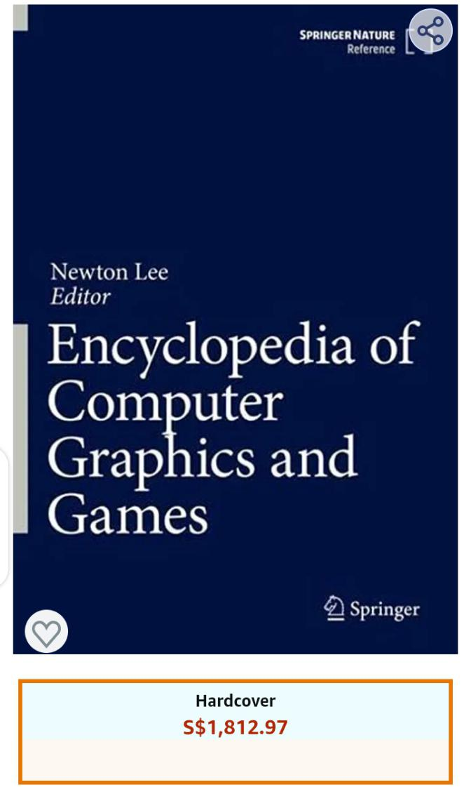

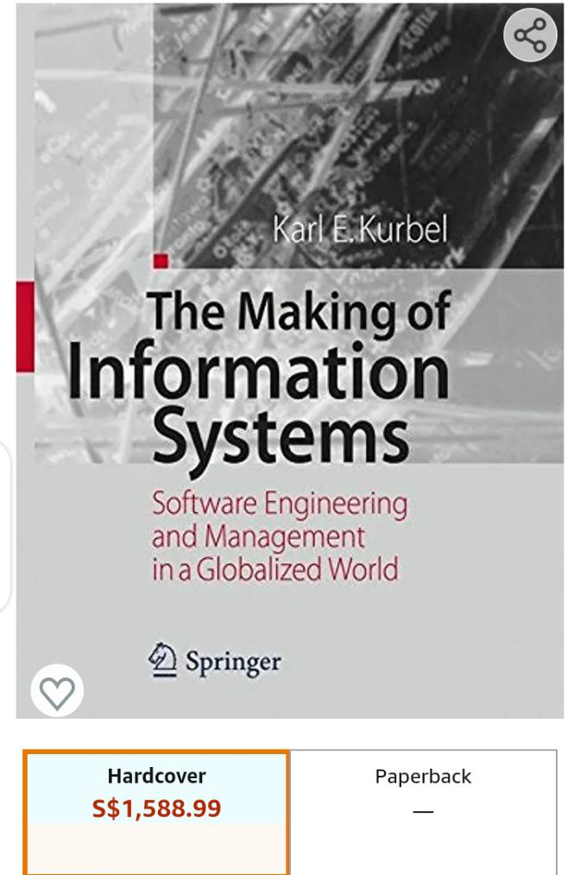

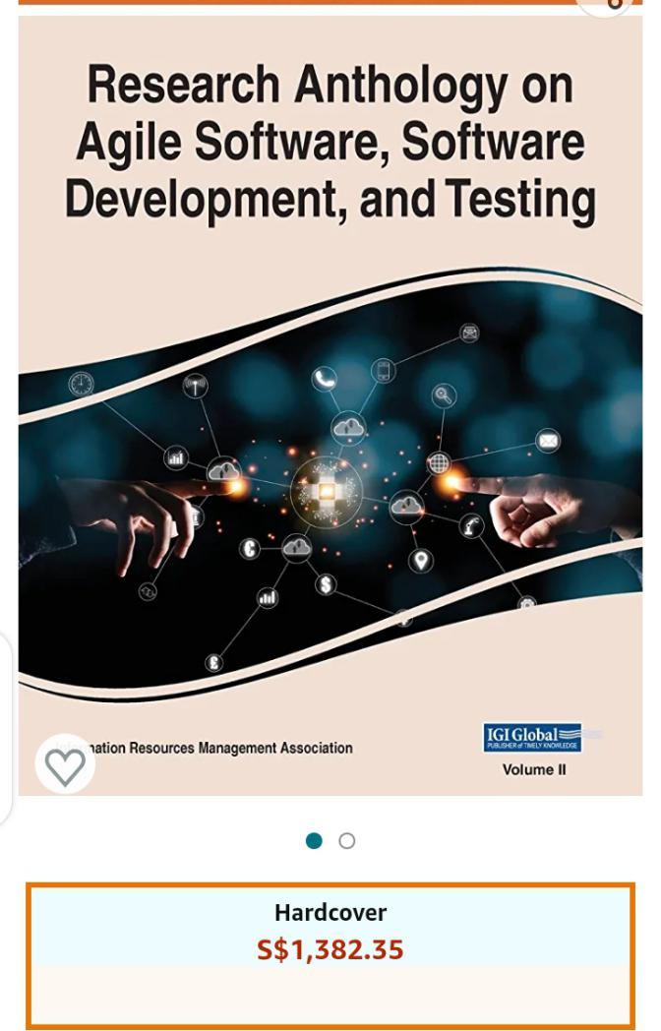

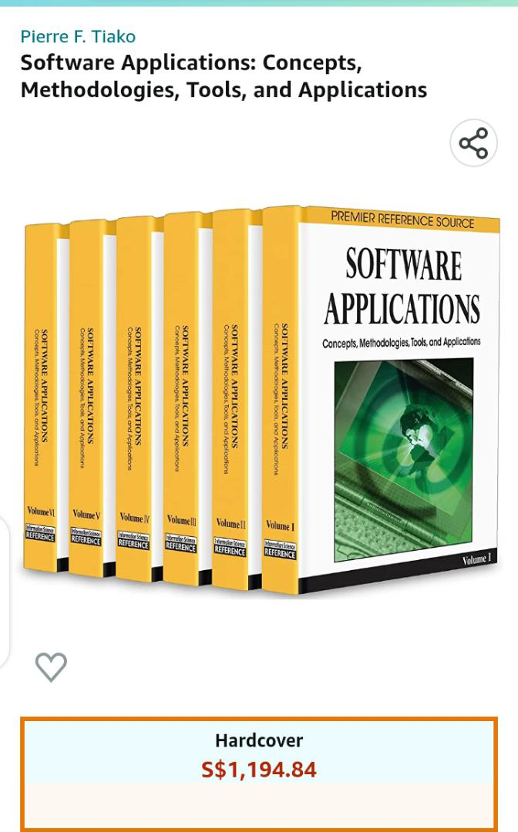

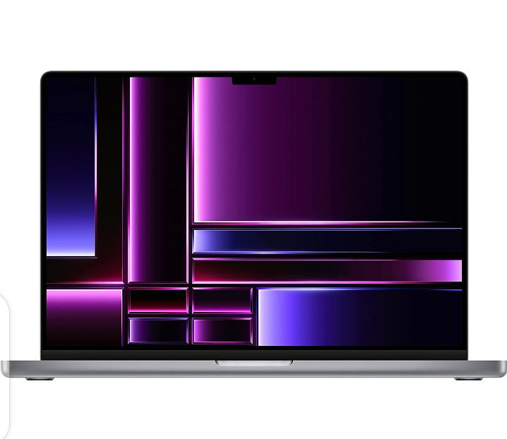

MacBook PRO 16 INCHES 2022

**SUMMARY OF THE TWO BUDGETS**

1. **Total budget = GH¢50,000.00**
2. **Conditional promises = GH¢27,000.00**
3. **DOLLAR-CEDI-RATE 1$ = GH¢10.50**

**Difference of total budget and conditional promises**

**GH¢50,000.00 - GH¢2700.00 = GH¢123,000.00**

**HENCE, THE NEW BUDGET NEEDED PROVIDED THE CONDITIONAL PROMISES ARE FULLY FULFILLED = GH¢123,000.00**

**By the above write-up and budget, I’m humbly soliciting for financial support from your humble outfit to be able to thrive in this one year Software Engineering Program. No amount is too small, no amount is too big. Give and the good Lord will bless you.**

**THANK YOU.**